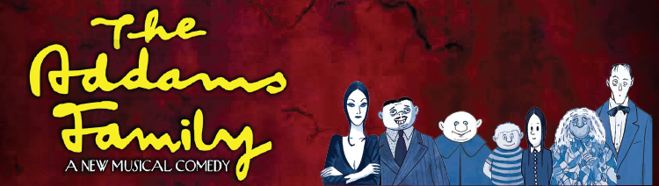

Costume Plot

Character | Costume 1 | Costume 2
Gomez Addams | Pinstripe Suit | Dinner Suit Smoking Jacket
Morticia Addams | Long Fitted Dress | Similar Dress with split for Tango De Amor
Unlce Festrer | Full Length Button Up Overcoat and Trousers  Flying Hat and Goggles | Stripy 1920's Style Bathing Suit*
Grandma Addams | ScruffyKnee Length Dress & Shawl
Wednesday Addams | Short Black Button Up Dress with White Collar and Black Leggings | Short Yellow Dress Similar in Style to First Dress  Short Black Button Up Coat
Pugsley Addams | Stripy T-Shirt and Shorts
Lurch | Morning Suit
Lucas Beineke | Blazer, Light Shirt, Dark T-Shirt, Tie and Chinos
Mal Beineke | Smart Three Piece Suit, Tie and Raincoat
Alice Beineke | Bright Dress and Overcoat
Ancestors | White & grey historical characters** with wig. NO SHOES ARE SUPPLIED | 1920's Bathing Suits (Female Ancestors Only for Moon and Me Number)

* This is for the Moon and Me number only if the staging does not have Fester dancing in mid air which requires a special costume with a false body attached to his lower half. We do not supply this specialised costume or false body.

** Ancestors will be allocated a character by best fit, please contact for sizes of costumes

